A 4-DAY-TRIP TO LONDON
( or another town in England)
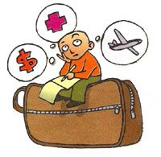Characteristics of the project
- Organize a trip to London by following the tasks proposed.
- You are going to stay 4 days in London (and their 3 nights!).
- Take note of every detail that is important to the organization of the trip: fares, departure and arrival times, luggage allowed, flight number, hotel facilities, organization of visits to places that is meaningful for your studies, opening times, means of transport...
- Remember that you won't be able to use Euros but Pounds. However, you need to provide your final budget in Euros.
- TASK 1 – Letter for the parents.
- TASK 2 – Practical information e.g. departure and arrival time, address, phone numbers, insurance, medicine etc.
- TASK 3 – Checklist e.g. what the student should not forget to bring
- Task 4 – Programme: per day and per hour. The places you want to visit have to relate to your studies. Include time to eat and explain how you get to places and how you get back.
- TASK 5 – the Costing: Calculate how much each student will need to pay in total e.g. transport costs, the entrance fee and catering: food and drink
- TASK 6 – Code of conduct: or how should we behave? List ten things you will do or behaviour you will demonstrate, to create a positive, caring, efficient and professional image whilst on the study visit.
- Add the your names and your class number on the front page of your booklet.

